SPENDWISE

1.INTRODUCTION :
Team Leader : Saumya R C
(Mail ID : 202400142@sigc.edu)
Team ID : SWTID-2026-8409
Team Members :
Ponmani B (Mail ID : 202400592@sigc.edu)
Shabarin Maxmeela G (Mail ID:202400681@sigc.edu)
Nathiya P (Mail ID : 202400370@sigc.edu)

2.PROJECT OVERVIEW :
SpendWise is a backend application created to help students understand how modern backend systems are built.
It demonstrates how secure REST APIs can be developed using Node.js, Express, MongoDB and JWT authentication.
The project allows users to register, log in securely and manage transaction records using basic
CRUD operation.

3.OBJECTIVES :
• Implement secure user authentication using JWT tokens
• Perform CRUD operations on transaction records
• Demonstrate MongoDB database integration using Mongoose
• Understand middleware for protecting private API routes
• Maintain a simple backend structure suitable for beginners

4. SOFTWARE REQUIREMENTS :
Node.js – JavaScript runtime
MongoDB – Database for storing project data
npm – Package manager
Git – Version control system
VS Code – Code editor

5. Technical Architecture :
• Controllers manage the business logic of authentication and transaction operations.

• Models define the database schemas using Mongoose.
• Routes define API endpoints used to interact with the application.
• Middleware verifies JWT tokens and protects private routes.
• Configuration files manage database connections and environment variables.

6. DATABASE ARCHITECTURE :
Users Collection: id, name, email, password createdAt
Transactions Collection: id, userId, title/description, amount/value, createdAt
Relationship: One user can have multiple transactions.

7. KEY FEATURES :
• User registration and login using JWT authentication
• CRUD operations for managing transaction data
• Protected API routes using authentication middleware
• MongoDB database integration using Mongoose.

8.PROJECT SETUP :
• Install Node.js and MongoDB.
• Create project folders: models, routes, controllers, middleware and config.
• Install dependencies such as express, mongoose, cors, jsonwebtoken, bcrypt and dotenv.
• Create server.js and .env files.
• Run the server using npm run dev

9. PROJECT EXECUTION :
• Start MongoDB database.
• Run the backend server.
• Use Thunder Client to test APIs
• Register a user and login to receive a JWT token.
• Use the token to access protected routes and perform CURD operations.

10. PROJECT CONFIGURATION :

FOLDER STRUCTURE :

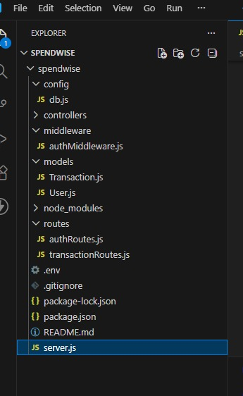

PROJECT SETUP :
- Install required tools:
• Node.js
• MongoDB
- Install Backend packages :
• Express
• Mongoose
• Cors
• Jsonwebtoken
• Bcrypt
• Dotenv

11. BACKEND DEVELOPMENT :

• .env file is created
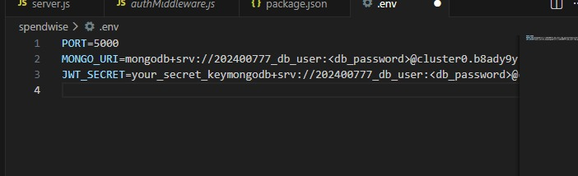

12. PROJECT EXECTION :

1. • MongoDB is started
• Backend server is run

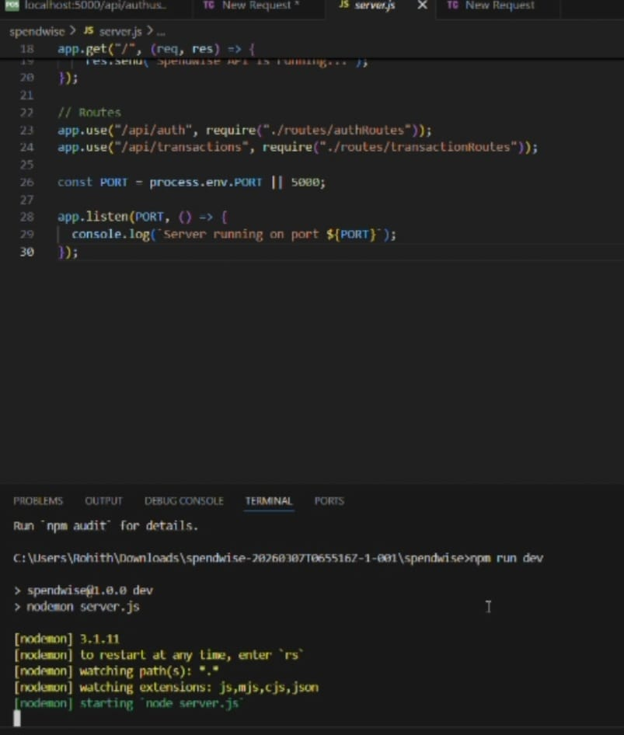

- Testing register API :

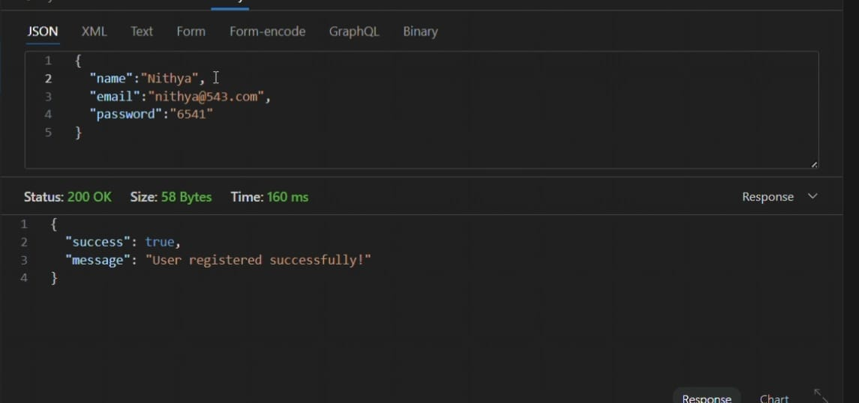

- Login API :

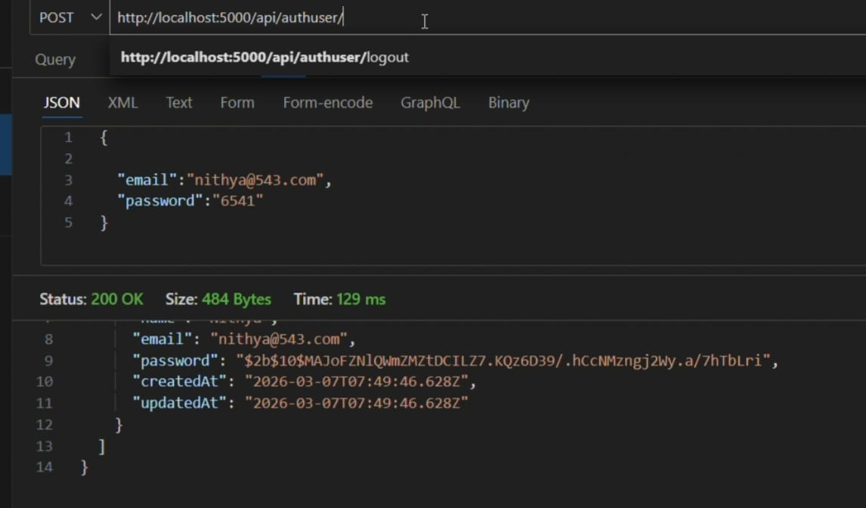
- JWT Token :

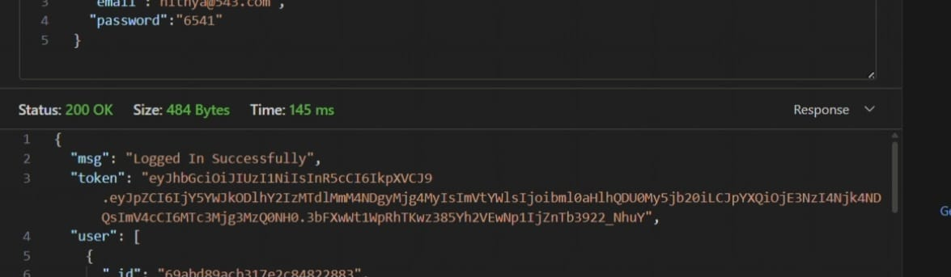

• Now the CURD APIs will be accessed by using this token.

13. OUTPUT :
- API Register :

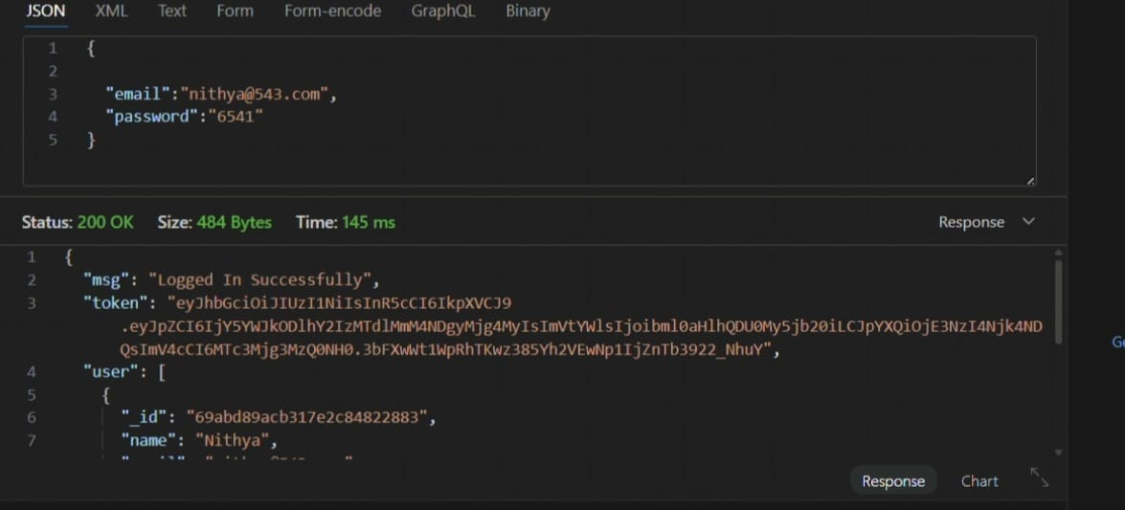
- API Login :



3.Transaction created :

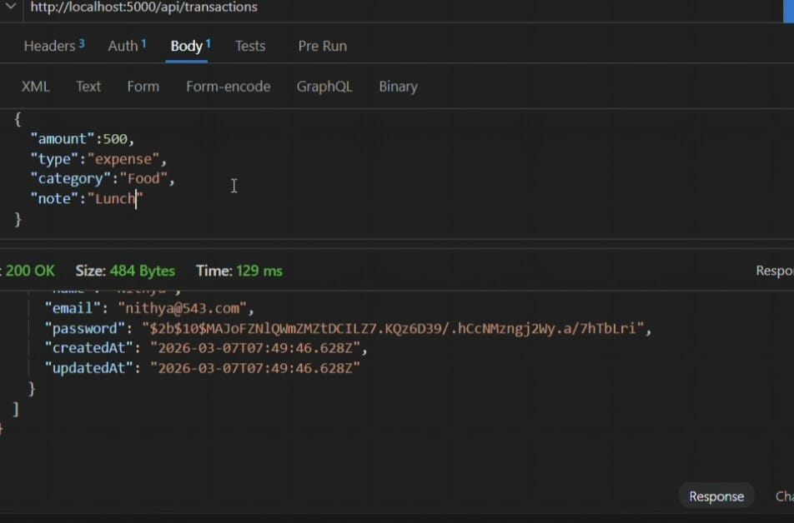
4 . Get information :

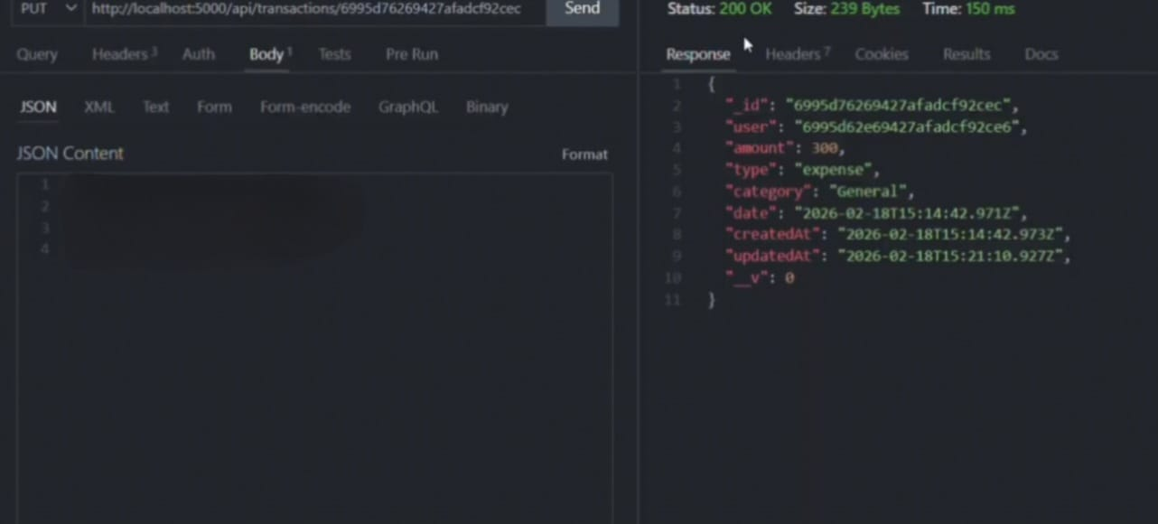

- Update API :

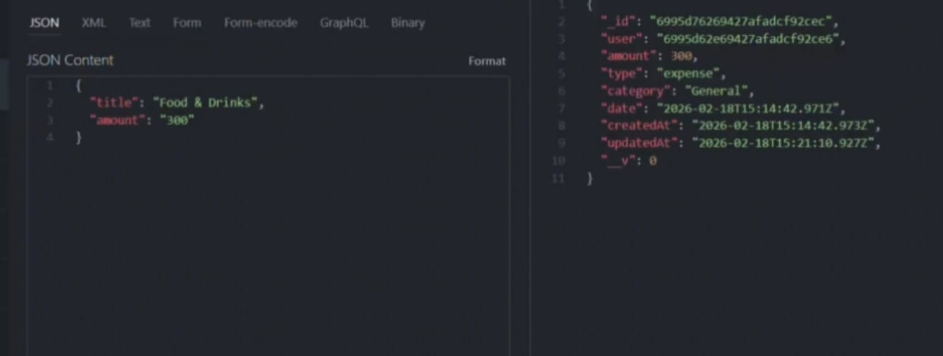

- API is deleted :

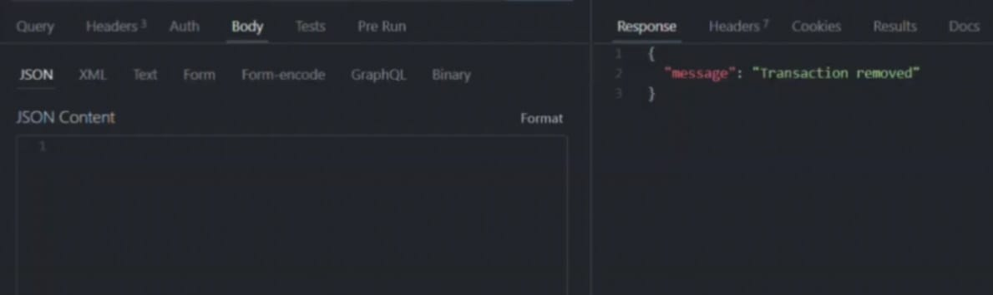
Now the API is removed.

Demo video link :
https://drive.google.com/file/d/1HlPsdbUFhoqN6YMvmGYbABimMGg2AeqR/view?usp=sharing

